# CS 255 System Design Document Template

## UML Diagrams

### UML Use Case Diagram

### UML Activity Diagrams

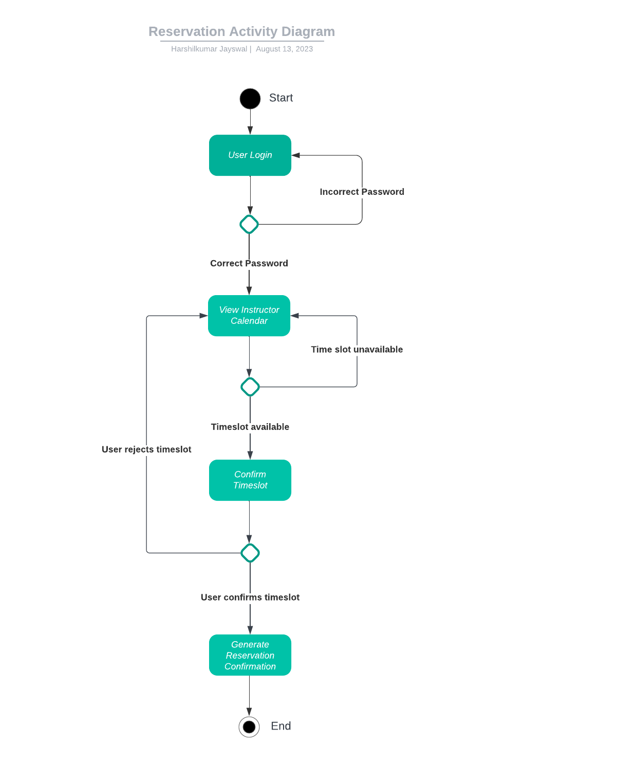

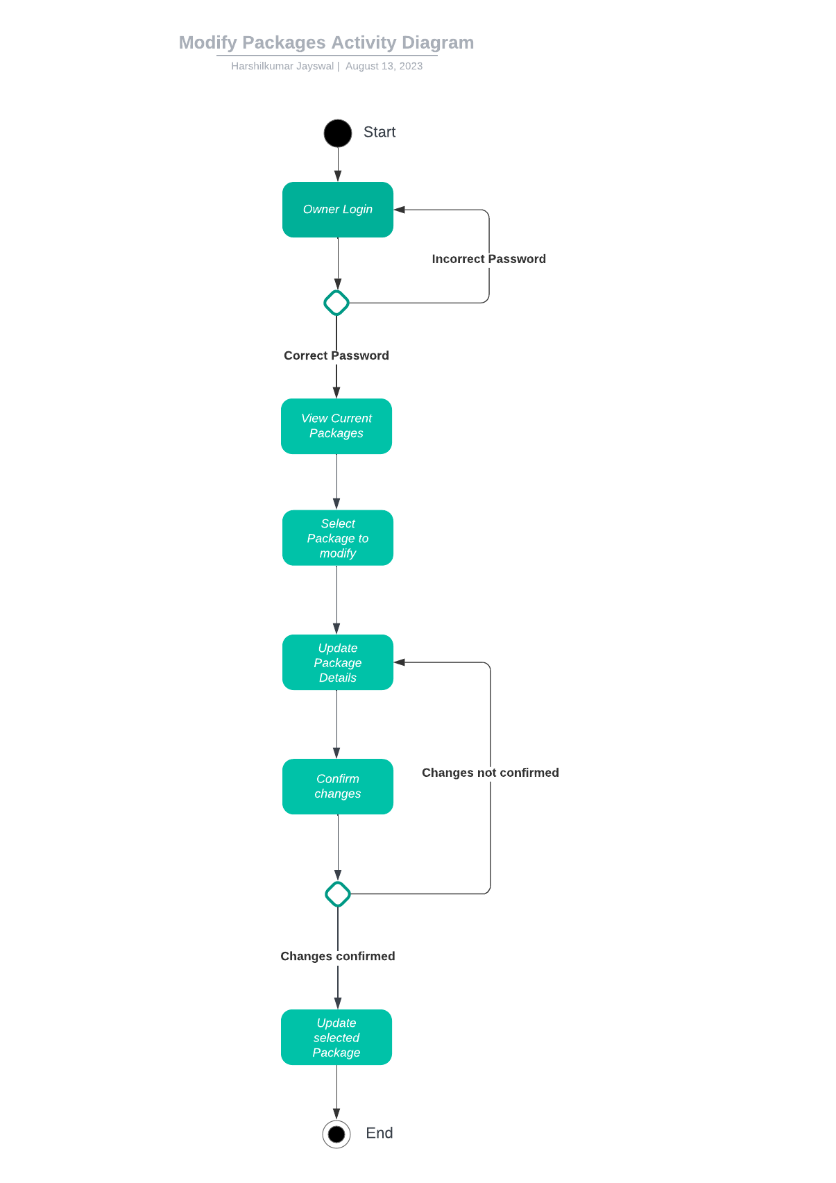

### UML Sequence Diagram

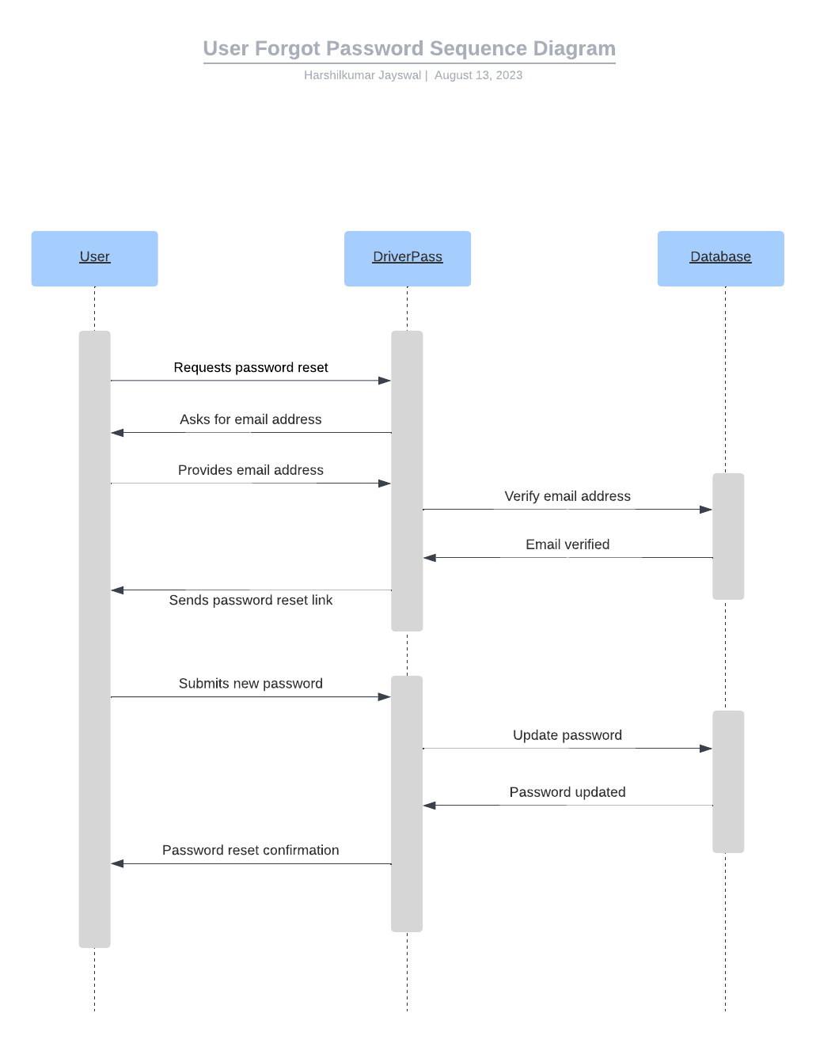

### UML Class Diagram

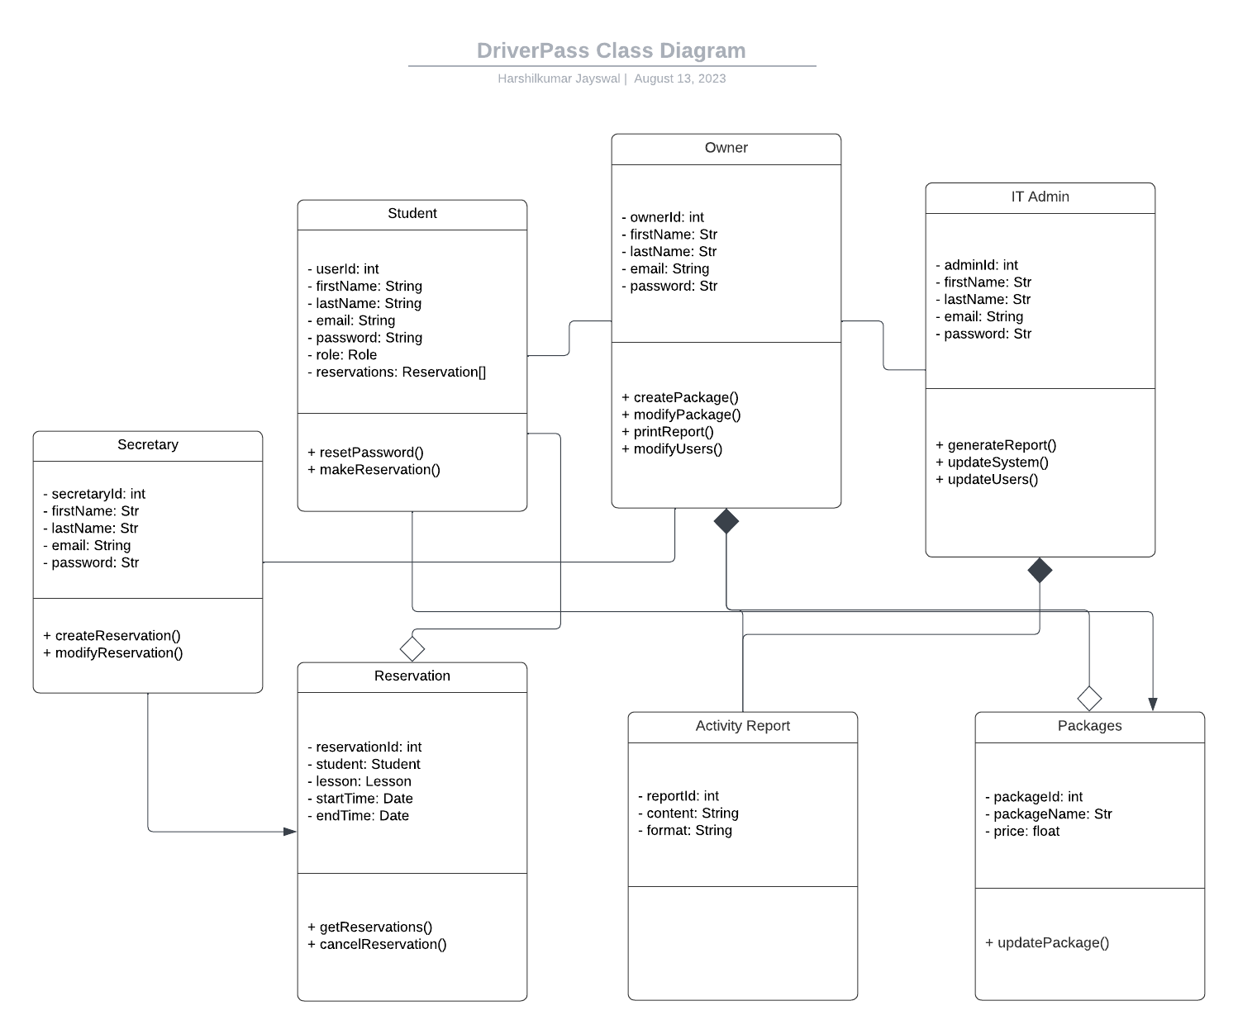

## Technical Requirements

Below are the technical requirements for DriverPass system that is hosted on cloud infrastructure

Hardware:

* DriverPass needs good servers to make the system work. This can be achieved by using secure and widely used cloud hosting infrastructure.
* The servers should have enough storage, memory and processing capacity to run the system 24/7 and should have minimal downtime.
* Reliable network equipment, including routers, switches, and firewalls, is essential for data transmission, security, and communication between different components.

Software:

* The servers should run a stable and secure operating system (e.g., Linux, Windows Server) capable of hosting web applications.
* A robust database management system is essential to manage and store user data, reservations, and system information.
* HTML, CSS, and JavaScript are necessary for building a responsive and user-friendly front-end interface. The front-end needs to be able to dynamically adjust to desktop or mobile devices.

Tools:

* Developers should use a suitable IDE (e.g., Visual Studio Code, Eclipse) for efficient coding and debugging.
* Tools like Jenkins or GitLab CI ensure automated testing, deployment, and system maintenance.

Infrastructure:

* As client noted we must use cloud services such as AWS or Azure for hosting and low maintenance since they provide industry leading solutions.
* There must be monitoring and activity logs capturing system so that IT Admin is able to monitor and assess security issues.